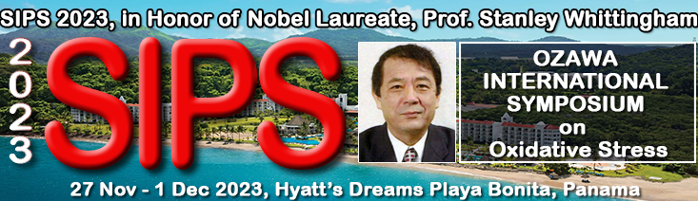
Dear colleague,

On behalf of Prof. Haruhiko Inufusa (TIMA/Gifu U., Japan), Prof. Christian Andre Amatore (CNRS & PSL, French Academy of Sciences, France), Prof. Hong-Yuan Chen (Nanjing U., China), Prof. Wei-Hua Huang (Wuhan U., China), Prof. Harry van Goor (UMCG, Netherlands) and Prof. Toshikazu Yoshikawa (Louis Pasteur Medical Research Center, Japan), cochairs of the Ozawa International Symposium on Oxidative Stress for Sustainable Development of Human Beings (3rd Intl. Symp.) , in my capacity as president of SIPS2023, I am personally inviting you to participate as an author/speaker to this major symposium dedicated to the lifetime achievements of Prof. Toshihiko Ozawa. Prof. Ozawa is a distinguished figure in understanding the role of oxidative stress on various diseases such as COVID-19 virus infection, allergy, aging, sleep apnea, reproduction, bacterial flora, cancer, etc. A special focus will be on the management of oxidative stress to control and/or fight and cure these diseases. Basic research as well as clinical research on antioxidants that serve this purpose are part of the focus of this symposium along with development of new antioxidants. All related subjects are also welcomed.

This is the third SIPS international symposium on oxidative stress. The previous ones were held in Rio de Janeiro, Brazil; Paphos, Cyprus and Phuket, Thailand. The full video recorded presentations from top world scientists during last year oxidative stress symposium are given in FLOGEN YouTube Channel link:
https://www.youtube.com/playlist?list=PLgoL_P_uAsGtq1xW_Rgy3xY3zxo24Tc4k
The upcoming presentations during SIPS 2023 will also be recorded and the videos will be available in full at FLOGEN YouTube channel.

This symposium is part of SIPS 2023, an annual multidisciplinary summit, organized by the not-for-profit corporation FLOGEN Stars Outreach (www.flogen.org), which is dedicated to achieving sustainability through science and technology applied in various fields. It incorporates summit plenary lectures from well-known speakers that address the link between various domains in the pursuit of sustainable development, as well as specific scientific symposia featuring specialized presentations in a specific domain, with the same goals in mind. The symposium and overall summit will be held in Panama from November 27th – December 1st 2023 in Hyatt’s Dreams Playa Bonita.
Please submit the abstract using this link: https://www.flogen.org/sips2023//abstract_submission.php?p=35#top4

Other additional information about this symposium, SIPS 2023 can be found in the official invitation: https://www.flogen.org/sips2023//pdf/Oxidative_General_Author_Invitation.pdf.

The papers will be double peer reviewed and published in the official Publication entitled: “Ozawa International Symposium on Oxidative Stress for Sustainable Development of Human Beings” containing ISBN and ISSN numbers and indexed by Google Scholar joining the existing 3000 SIPS articles (https://bit.ly/3qRrdGt). Furthermore, many papers will be subsequently published as part of special volume of relevant Journal dedicated to this symposium.

As an invitee, if you prefer to deliver a presentation with a wider scope for one of the listed topics, or on a new specialized topic of your choice, we would be pleased to take it into consideration for a possible nomination as an Invited or Keynote Lecture.

In this case, please send us an email at the same address, which should indicate your interest and include a draft abstract.

Pertinent information from our website:

SIPS 2022 Video Synopsis of 23 minutes: https://www.youtube.com/watch?v=kUyfcO6QbKY
Some videos from previous SIPS Symposiums are presented here: https://flogen.org/?p=71
SIPS impressions over the years: https://flogen.org/?p=110
Video impression over the years: https://flogen.org/?p=79
Highlights of FLOGEN and SIPS activities https://www.flogen.org/?p=105
Hall of Fame: https://www.flogen.org/?p=92

*An overview of previous SIPS held at various locations all over the world (USA, Mexico, Turkey, China, Brazil, Cyprus, Thailand) can be found here: https://flogen.org/?p=32&an=2002

The symposium is the optimal conference to present your most recent work, listen to the latest achievements of your colleagues, and interact with well-known experts from diverse fields of industry, academia, and politics. We hope your participation will enable your organization to improve efficacy and implement the best sustainable research and industrial practices.

It would be a great pleasure to have you join us. We are looking forward to hearing from you.

Dr. Florian Kongoli
President SIPS 2023
Organizing Committee

FLOGEN Stars OUTREACH
(Not-for-profit corporation)
Giving STAR Power to Scientists, Technologists and Engineers and to People Who Help Them
1255 Laird Blvd., Ste. 388-1, Mont-Royal, QC, Canada, H3P2T1
Toll-Free (N. America): +1-877-2-FLOGEN Tel: +1-514 807 8542 Fax: +1-514-344-0361; Web site:
www.flogen.org E-mail: secretary@flogen.org

